Setup DB MySQL using MySQL WorkBench:

1. Tables in DB shop:
   1. 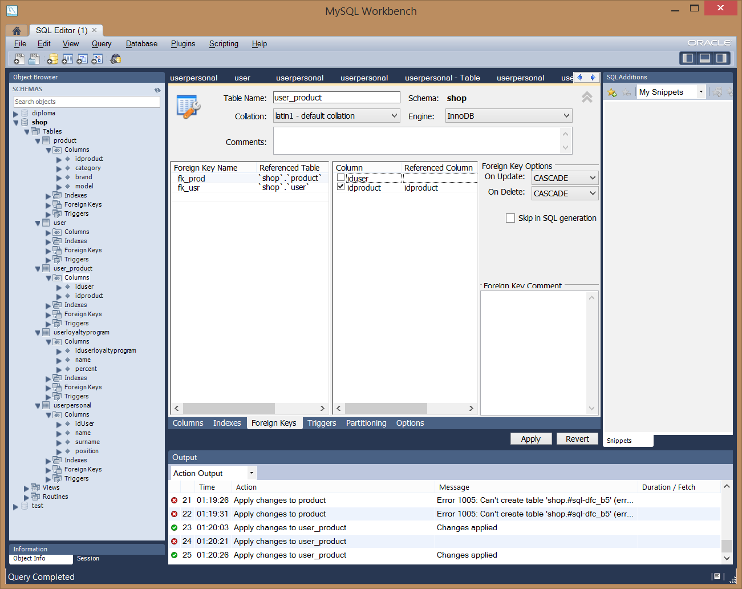
2. Example FKs:
   1. 
3. User table:

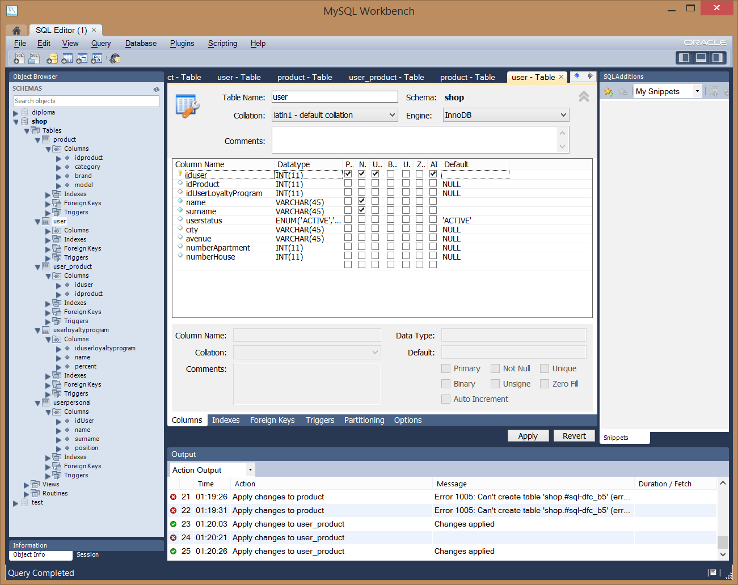

1. Table user_product (for many-to-many relationship):
   1. 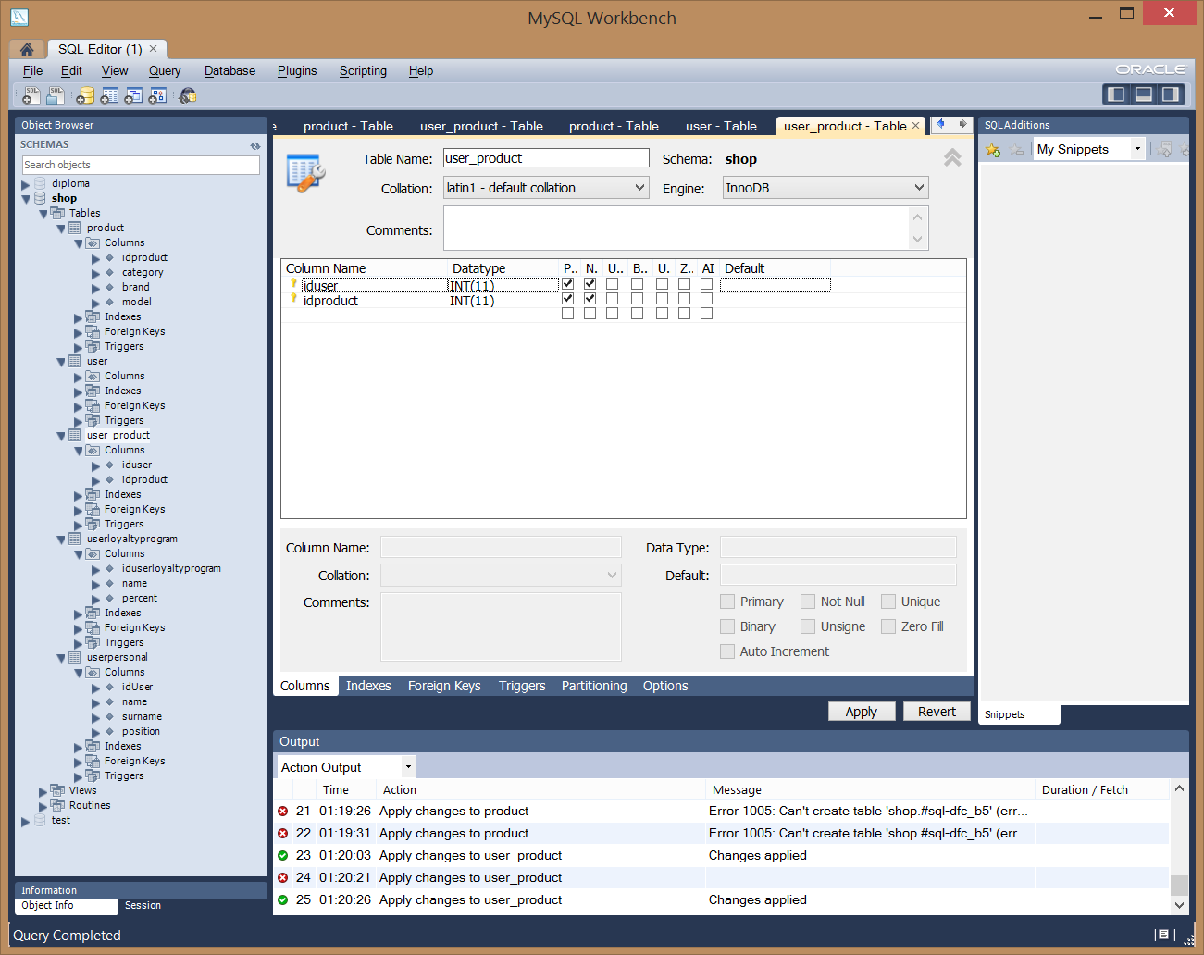
2. Product table:

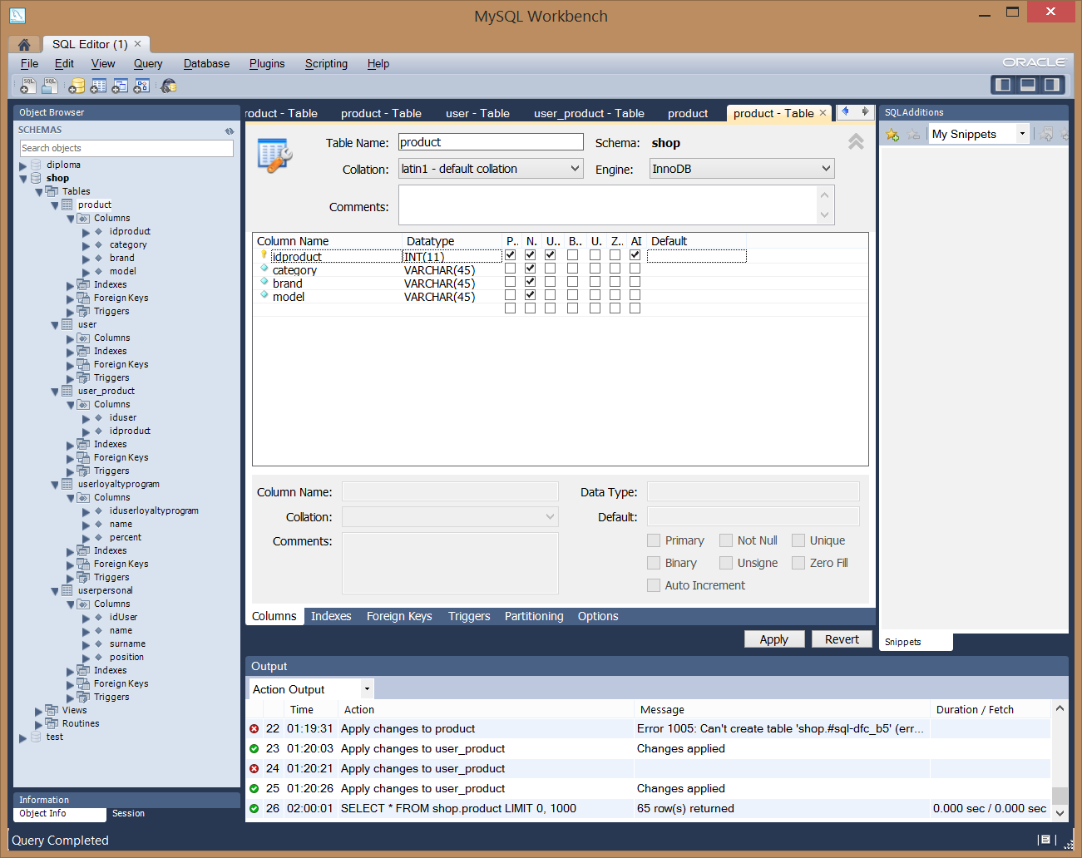

1. UserLoyaltyProgram:

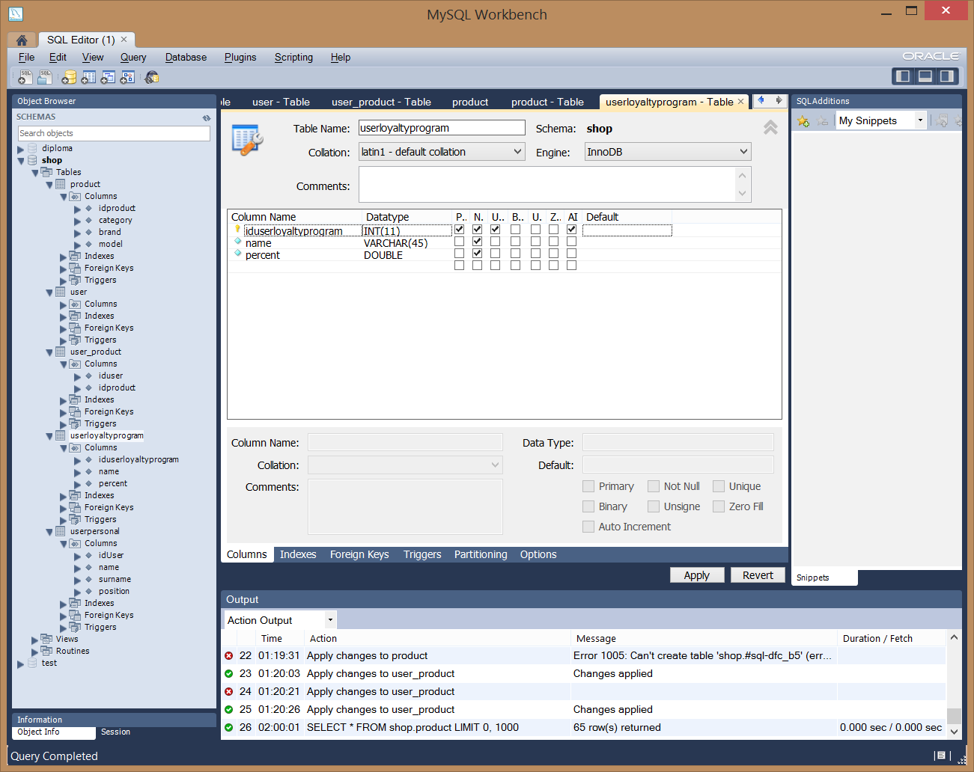

1. UserPersonal

